

# TERM- I

**A PROJECT SYNOPSIS**

# On

COVID Vaccination Survey

Submitted By

# Mr. Yash Bhake

2021-2022

Under the Guidance of

# Mrs. Shahjahan Shaikh

Submitted in partial fulfilment of the requirement for qualifying XII/CBSE/2021-2022/Board Examination

Apeejay School Nerul, Navi Mumbai

# CERTIFICATE



This is to certify that the Project Entitled **COVID Vaccination Survey** undertaken at the **Apeejay School, Nerul, Navi Mumbai** by

Mr Yash Bhake in partial fulfilment of the requirement for qualifying TERM-I COMPUTER SCIENCE XII/CBSE/2021-2022 Examination. It is further certified that he/she has completed all required phases of the Project.

Signature of Internal Guide Signature of Principal

School Seal

# TABLE OF CONTENTS

1. Introduction
2. Literature Survey
3. Hardware and Software Requirement
4. Block diagram of a project
5. Description of the Packages/Modules used
6. Conclusion
7. Future Scope
8. Bibliography

# Introduction

Our project is titled ‘COVID Vaccination Survey’. The Covid-19 pandemic has altered the world’s health sector drastically. Thus in the year 2021 vaccines were made available to the people of our country. But these vaccines are needed to be monitored so as to make them more efficient in the future. Our project is an attempt to design an efficient interactive menu oriented interface which monitors the symptoms/side effects after taking a particular vaccine. The information collected will be stored in a database, and various plots have been created using this information, which can help catch any trend or any flaw and may help Vaccine brands Aware of The effects of the vaccines on the people. It is designed in a way that the user is able to understand the system with ease. It asks the user to register his/her name for his/her chosen vaccine, after which it gives the user a unique registration number. After taking the shot it asks for symptoms (if any). It then takes all the inputs given, stores them in the database and plots the graphs accordingly.

The main aim of this project is to make the healthcare sector aware of the symptoms of the vaccines and help them make the vaccines more efficient. We assure that our project works in an coherent and hassle-free way. The whole process is also very time efficient.

MySQL tables used in the program:

1. userinfo
2. vaccination

**Literature Survey**

This project is inspired from the Government of India app Aarogya Setu, which amidst this pandemic, has played a vital role. This app has made the Vaccination process much simpler and smooth.

This app is an immense, in the whole covid scenario, We got very much inspired by its well functioning, and ability to analyze data collected from a huge population, and seamlessly providing the user with various graphs and plots.

**Hardware and Software requirement**

1. HARDWARE REQUIREMENTS:

o x86 64‐bit CPU (Intel / AMD architecture)

o 4 GB RAM,5 GB free disk space

1. SOFTWARE REQUIREMENTS:

o Operating system:

Linux‐ Ubuntu 16.04 to 17.10

Windows 7 to 10 with 2GB RAM (4GB preferable)

o Python IDLE(3.8‐32\64bit)

o MySQL

o Matplotlib and Pillow Python library.

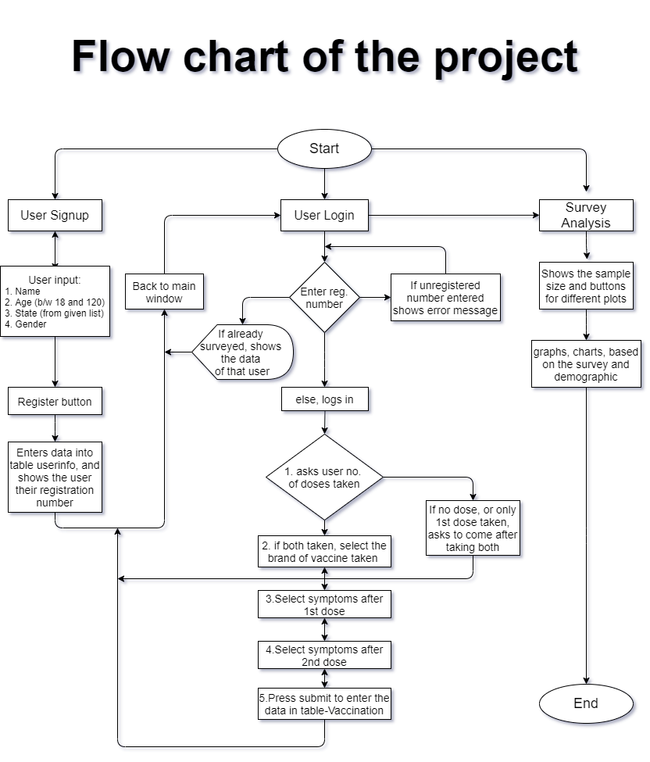

**Description of the Packages/Modules used**

1. MySQL Connector:

MySQL Connector/Python enables Python programs to access MySQL databases using an API that is compliant with the Python.

It is written in pure Python and does not have any dependencies except for the Python Standard Library.

1. OS:

The OS module in Python provides functions for interacting with the operating system. OS comes under Python's standard utility modules. This module provides a portable way of using operating system-dependent functionality. We have used this for getting the image address from the folder where the .py file is stored

1. Pillow:

Python pillow library is used to image class within it to show the image. The image modules that belong to the pillow package have a few inbuilt functions such as load images or create new images, etc. We have used this module just for some igame resizing and applying some as wallpaper, for a userfriendly look, this is totally optional, so our code doesn’t depend on the availability of this module on any other devices

1. Matplotlib:

Matplotlib is a plotting library for the Python programming language and its numerical mathematics extension NumPy. It provides an object-oriented API for embedding plots into applications using general-purpose GUI toolkits like Tkinter, Qt etc. We have used this awesome library for creating graphs and plots of the data we collected using this survey, the graphs in this module are interactive too.

1. NumPy:

NumPy is a Python library used for working with arrays. It also has functions for working in domain of linear algebra, fourier transform, and matrices. It comes under matplotlib, and some of matpotlib’s coding requires NumPy arrays.

1. Tkinter:

Tkinter is the standard GUI library for Python. Python when combined with Tkinter provides a fast and easy way to create GUI applications. Tkinter provides a powerful object-oriented interface to the Tk GUI toolkit. Our user interface is built using this library.

**Conclusion**

This project is a very user-friendly and shows the status of the vaccine available to the common man. Survey helps the person to choose the appropriate vaccine for him/her and for their loved ones. It also helps the Pharmaceutical Companies for analysing and manipulating their vaccines. The project is inspired by the current situation of the world. Thus our project “COVID Vaccination Survey” an efficient interactive menu oriented interface which monitors the symptoms/side effects after taking a particular vaccine. The information collected is stored in a database, and various plots have been created using this information, which can help catch any trend or any flaw. This project is can be seen as a template for surveys and its analysis, our project provides a jist of it, which may be further developed into a more practical and purposeful application that can help the nation.

**Future Scope**

The project can be a template for better larger practical projects, which may have a great impact in this crisis. Though it has a few limitations such as it can run on specific devices (i.e. it cant run on the mobile phones which are generally used by all the people.) . This program is not compatible with the Internet, it runs only on local Computers with compatible Operating System having MySQL, Matplotlib and Pillow Python libraries installed. These limitations can be rectified and the program can be developed further for mass use which may help us understand and analyse the biological threats that may arise in the future and their cures.

**Bibliography**

* Computer Science with Python for class XII by Sumita Arora
* [www.geeksforgeeks.com](http://www.geeksforgeeks.com)
* [www.tutorialspoint.com](http://www.tutorialspoint.com)
* www.stackoverflow.com
* [www.youyube](http://www.youyube)
* [www.python-course.eu](http://www.python-course.eu)
* [www.javapoint.com](http://www.javapoint.com)